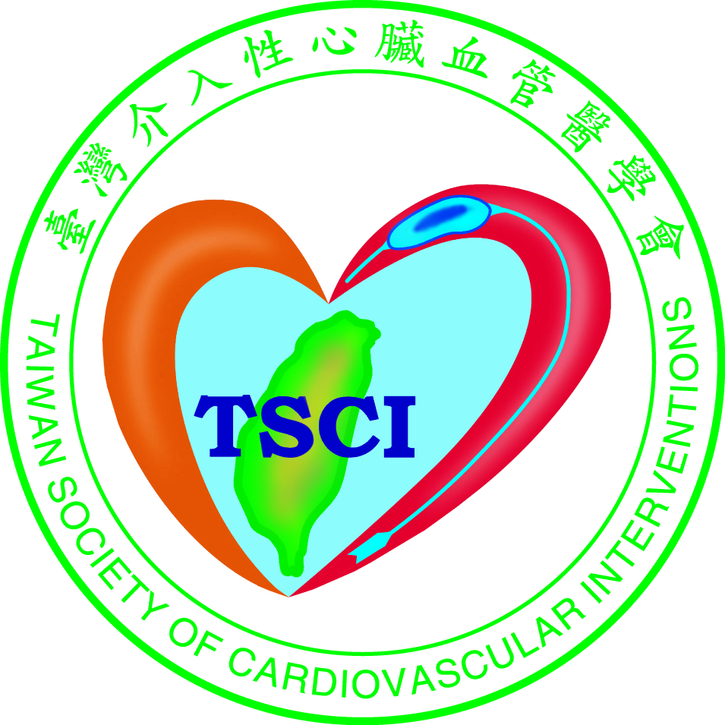
臺灣介入性心臟血管醫學會
Hot Topics in Transcatheter Heart Valve Interventions TAVR and TMVr
時間：110年3月20日 13:30-16:50 地點：臺大醫學院102講堂
贊助廠商：美敦力醫療產品股份有限公司/台灣雅培醫療器材有限公司/台灣愛德華生命科學股份有限公司
時間 | 講題 | 講師 | 座長
13:30 | Opening | 謝宜璋 理事長
13:35 | Changes in Mitra Clip Patient Selection: Past & Present | 宋思賢 | 許榮城
13:55 | Q & A (5 mins)
14:00 | TAVR in Low Risk Patients - Literature Up to Date | 李慶威 | 謝宜璋
14:20 | Q & A (5 mins)
14:25 | Indications for TAVR - How Would You Treat in The Future? | 林茂欣
14:45 | Q & A (5 mins)
14:50 | Coffee Break
15:05 | TAVR Optimization Strategies in Complex Anatomies | 李建和 | 鄭正一
15:25 | Q & A (5 mins)
15:30 | Tips and Tricks of Valve in Valve: Focus on Stentless Valve, Fracturing... | 李永在 | 殷偉賢
15:50 | Q & A (5 mins)
15:55 | TAVR Device Selection: A Patient-Oriented Algorithm | 曹殿萍
16:15 | Q & A (5 mins)
16:20 | Strategies to minimize conduction disturbances following TAVR with self-expanding valves and Cusp Overlap technique | 陳嬰華 | 劉尊睿
16:40 | Q & A (5 mins)
16:45 | Closing | 殷偉賢 副院長

